VISVESVARAYA TECHNOLOGICAL UNIVERSITY

“JnanaSangama”, Belgaum -590014, Karnataka.



LAB REPORT

on

OPERATING SYSTEMS

Submitted by

VANSH GANDHI (1WA23CS030)

in partial fulfillment for the award of the degree of

# BACHELOR OF ENGINEERING

in

COMPUTER SCIENCE AND ENGINEERING



B.M.S. COLLEGE OF ENGINEERING

(Autonomous Institution under VTU)

BENGALURU-560019

Feb-2025 to June-2025

B. M. S. College of Engineering,

Bull Temple Road, Bangalore 560019

(Affiliated To Visvesvaraya Technological University, Belgaum)

Department of Computer Science and Engineering



CERTIFICATE

This is to certify that the Lab work entitled “OPERATING SYSTEMS – 23CS4PCOPS” carried out by VANSH GANDHI(1WA23CS030), who is Bonafide student of B. M. S. College of Engineering. It is in partial fulfilment for the award of Bachelor of Engineering in Computer Science and Engineering of the Visvesvaraya Technological University, Belgaum during the year Feb 2025- June 2025. The Lab report has been approved as it satisfies the academic requirements in respect of a OPERATING SYSTEMS - (23CS4PCOPS) work prescribed for the said degree.

Dr Seema Patil Dr. Kavitha Sooda

Assistant Professor Professor and Head

Department of CSE Department of CSE

BMSCE, Bengaluru BMSCE, Bengaluru

Index Sheet

|  |  |  |
| --- | --- | --- |
| Sl.  No. | Experiment Title | Page No. |
| 1. | Write a C program to simulate the following non-pre-emptive CPU scheduling algorithm to find turnaround time and waiting time.  →FCFS  → SJF (pre-emptive & Non-preemptive) | 1-17 |
| 2. | Write a C program to simulate the following CPU scheduling algorithm to find turnaround time and waiting time.  → Priority (pre-emptive & Non-pre-emptive)  →Round Robin (Experiment with different quantum sizes for RR algorithm) | 18-30 |
| 3. | Write a C program to simulate multi-level queue scheduling algorithm considering the following scenario. All the processes in the system are divided into two categories – system processes and user processes. System processes are to be given higher priority than user processes. Use FCFS scheduling for the processes in each queue. | 30-38 |
| 4. | Write a C program to simulate Real-Time CPU Scheduling algorithms:   1. Rate- Monotonic 2. Earliest-deadline First 3. Proportional scheduling | 39-48 |
| 5. | Write a C program to simulate producer-consumer problem using semaphores | 49-54 |
| 6. | Write a C program to simulate the concept of Dining Philosophers problem. | 54-61 |
| 7. | Write a C program to simulate Bankers algorithm for the purpose of deadlock avoidance. | 62-67 |
| 8. | Write a C program to simulate deadlock detection | 68-71 |
| 9. | Write a C program to simulate the following contiguous memory allocation techniques a) Worst-fit   1. Best-fit 2. First-fit | 72-83 |
| 10. | Write a C program to simulate page replacement algorithms a) FIFO   1. LRU 2. Optimal | 84-92 |

Course Outcomes

|  |  |
| --- | --- |
| C01 | Apply the different concepts and functionalities of Operating System |
| C02 | Analyse various Operating system strategies and techniques |
| C03 | Demonstrate the different functionalities of Operating System. |
| C04 | Conduct practical experiments to implement the functionalities of Operating system. |

Program -1

Question:

Write a C program to simulate the following non-pre-emptive CPU scheduling algorithm to find turnaround time and waiting time.

→FCFS

→ SJF (pre-emptive & Non-preemptive)

Code:

#include <stdio.h>

void main() {

int n;

printf("Enter number of processes: ");

scanf("%d", &n);

int arrival[n], burst[n], waiting[n], turnaround[n], completion[n], response[n];

printf("Enter Arrival Time and Burst Time for each process:\n");

for (int i = 0; i < n; i++) {

printf("Process %d: ", i + 1);

scanf("%d %d", &arrival[i], &burst[i]);

}

int currentTime = 0;

float totalWaiting = 0, totalTurnaround = 0;

printf("\nProcess\tArrival\tBurst\tWaiting\tTurnaround\tResponse\n");

for (int i = 0; i < n; i++) {

if (currentTime < arrival[i])

currentTime = arrival[i];

completion[i] = currentTime + burst[i];

turnaround[i] = completion[i] - arrival[i];

waiting[i] = turnaround[i] - burst[i];

response[i] = completion[i] - arrival[i];

totalWaiting += waiting[i];

totalTurnaround += turnaround[i];

printf("%d\t%d\t%d\t%d\t%d\t\t%d\n", i + 1, arrival[i], burst[i], waiting[i], turnaround[i], response[i]);

currentTime = completion[i];

}

printf("\nAverage Waiting Time: %.2f", totalWaiting / n);

printf("\nAverage Turnaround Time: %.2f\n", totalTurnaround / n);

}

Result:

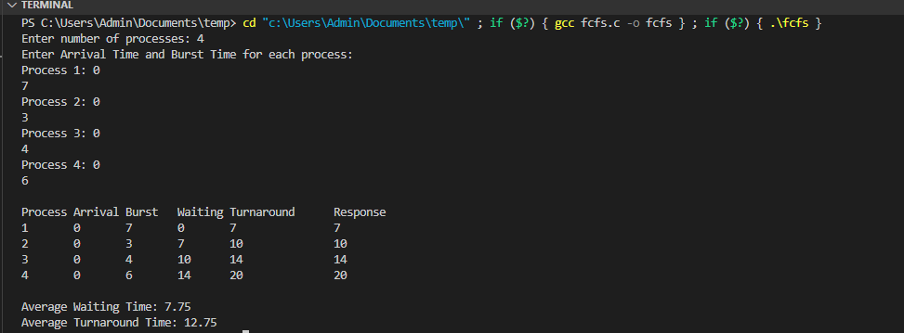

=>SJF(Non-preemptive):

Code:

#include <stdio.h>

void nonPreemptiveSJF(int n, int at[], int bt[], int ct[], int tat[], int wt[], int rt[])

{

int completed = 0, time = 0, min_bt, shortest, finish_time;

int remaining_bt[n];

for (int i = 0; i < n; i++)

{

remaining_bt[i] = bt[i];

}

while (completed < n)

{

min_bt = 9999;

shortest = -1;

for (int i = 0; i < n; i++)

{

if (at[i] <= time && remaining_bt[i] > 0 && bt[i] < min_bt)

{

min_bt = bt[i];

shortest = i;

}

}

if (shortest == -1)

{

time++;

continue;

}

time += bt[shortest];

remaining_bt[shortest] = 0;

completed++;

ct[shortest] = time;

tat[shortest] = ct[shortest] - at[shortest];

wt[shortest] = tat[shortest] - bt[shortest];

rt[shortest] = wt[shortest];

}

}

void displayTable(int n, int at[], int bt[], int ct[], int tat[], int wt[], int rt[])

{

printf("\nProcess\tAT\tBT\tCT\tTAT\tWT\tRT\n");

for (int i = 0; i < n; i++)

{

printf("%d\t%d\t%d\t%d\t%d\t%d\t%d\n", i + 1, at[i], bt[i], ct[i], tat[i], wt[i], rt[i]);

}

}

int main()

{

int n;

printf("Enter number of processes: ");

scanf("%d", &n);

int at[n], bt[n], ct[n], tat[n], wt[n], rt[n];

printf("Enter Arrival Time and Burst Time for each process:\n");

for (int i = 0; i < n; i++)

{

printf("Process %d - Arrival Time: ", i + 1);

scanf("%d", &at[i]);

printf("Process %d - Burst Time: ", i + 1);

scanf("%d", &bt[i]);

}

nonPreemptiveSJF(n, at, bt, ct, tat, wt, rt);

displayTable(n, at, bt, ct, tat, wt, rt);

return 0;

}

Output:

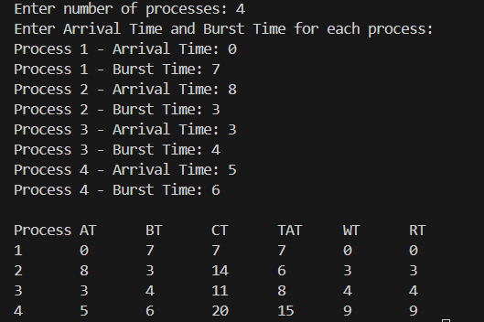

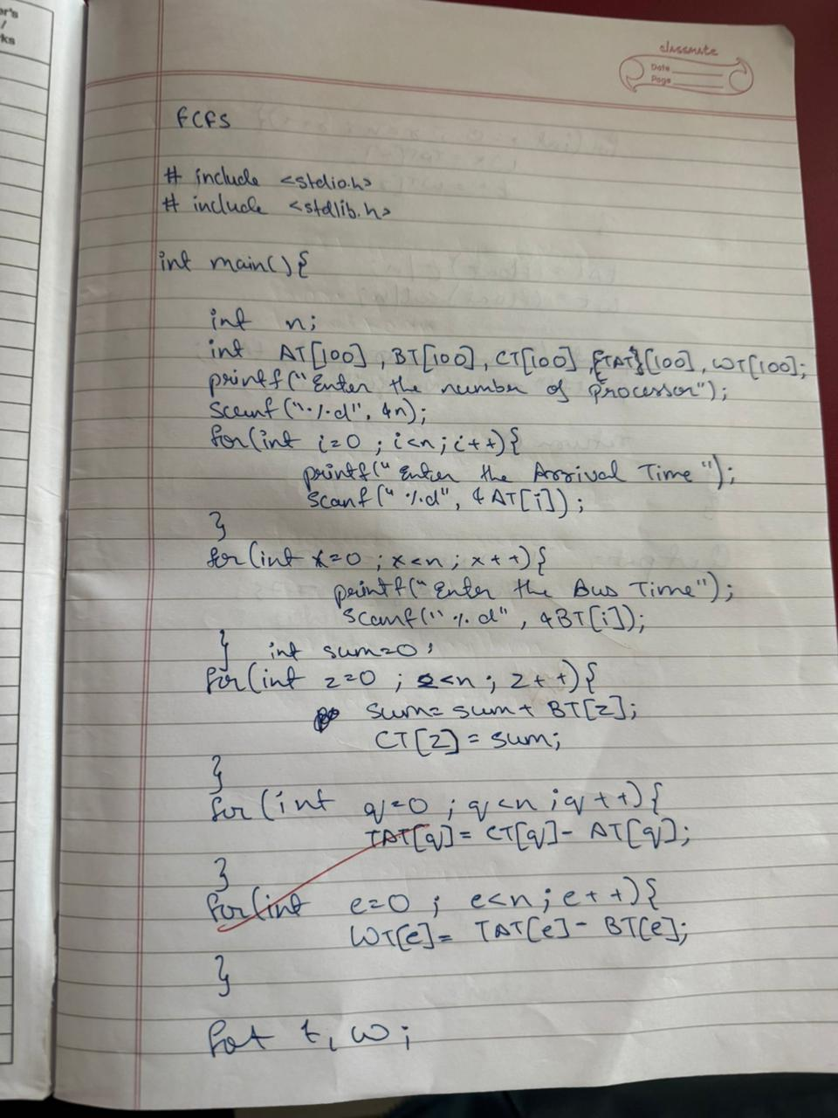

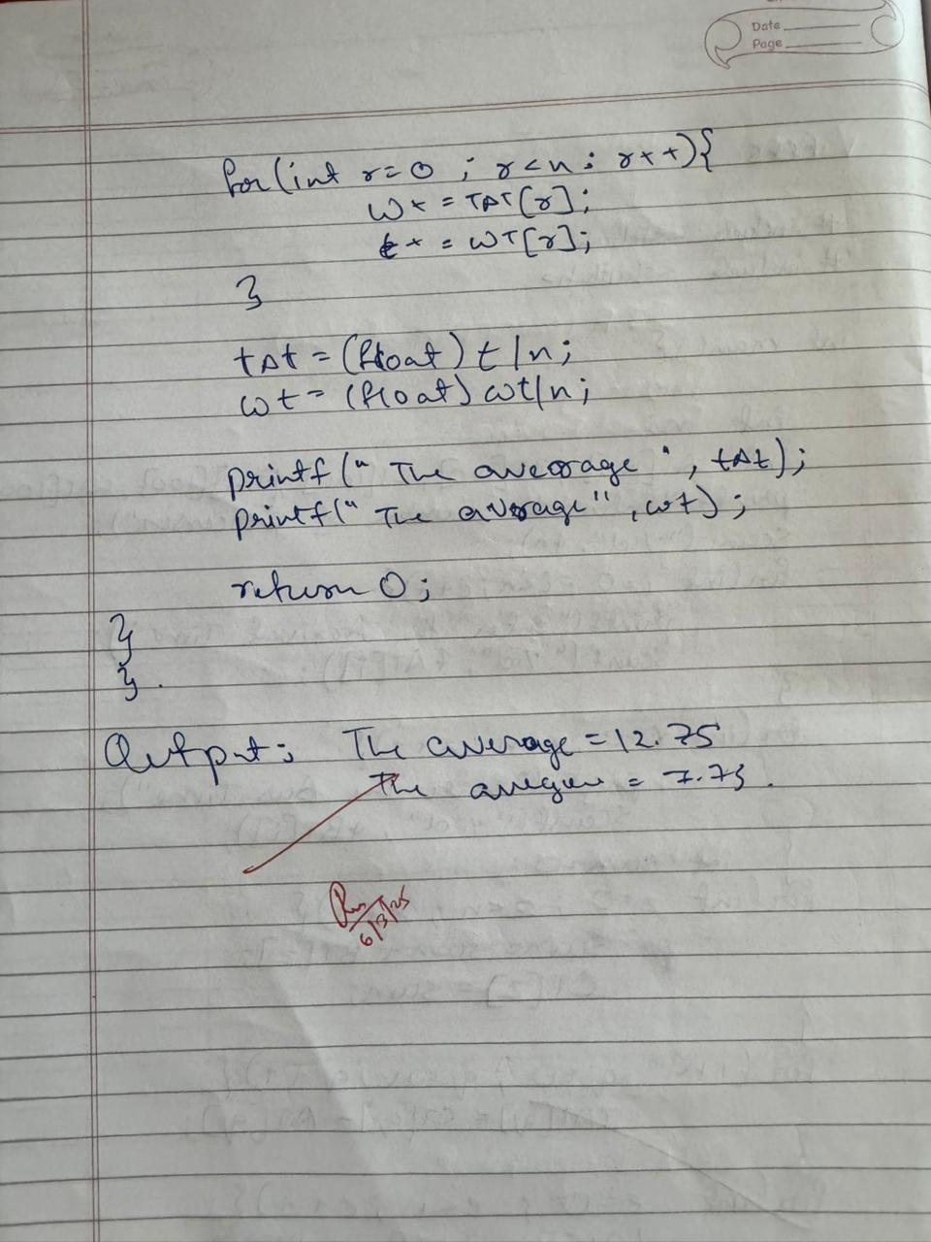

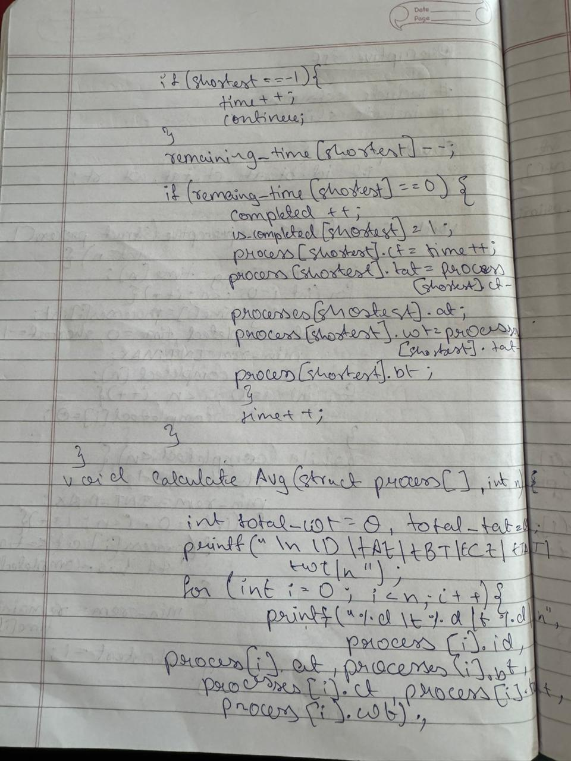

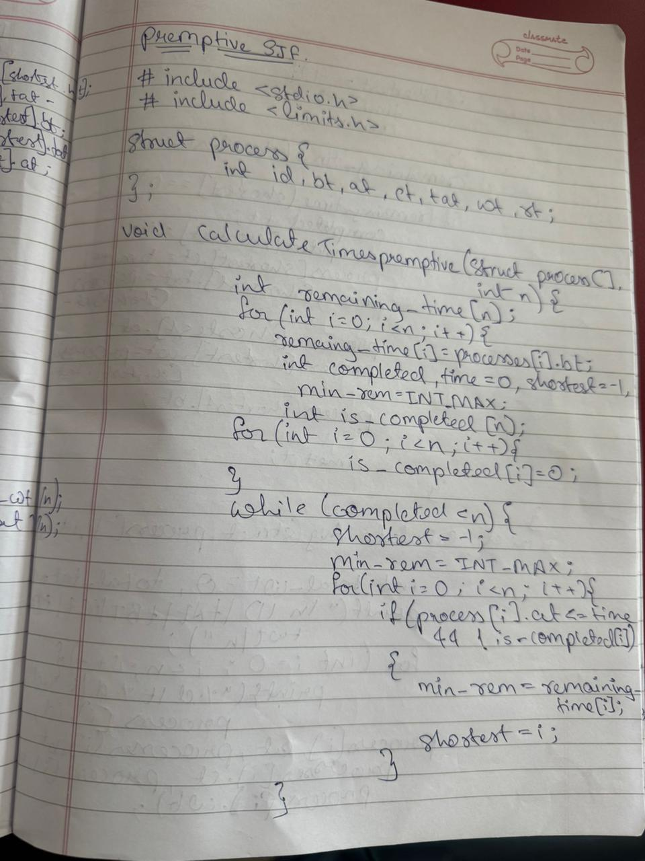

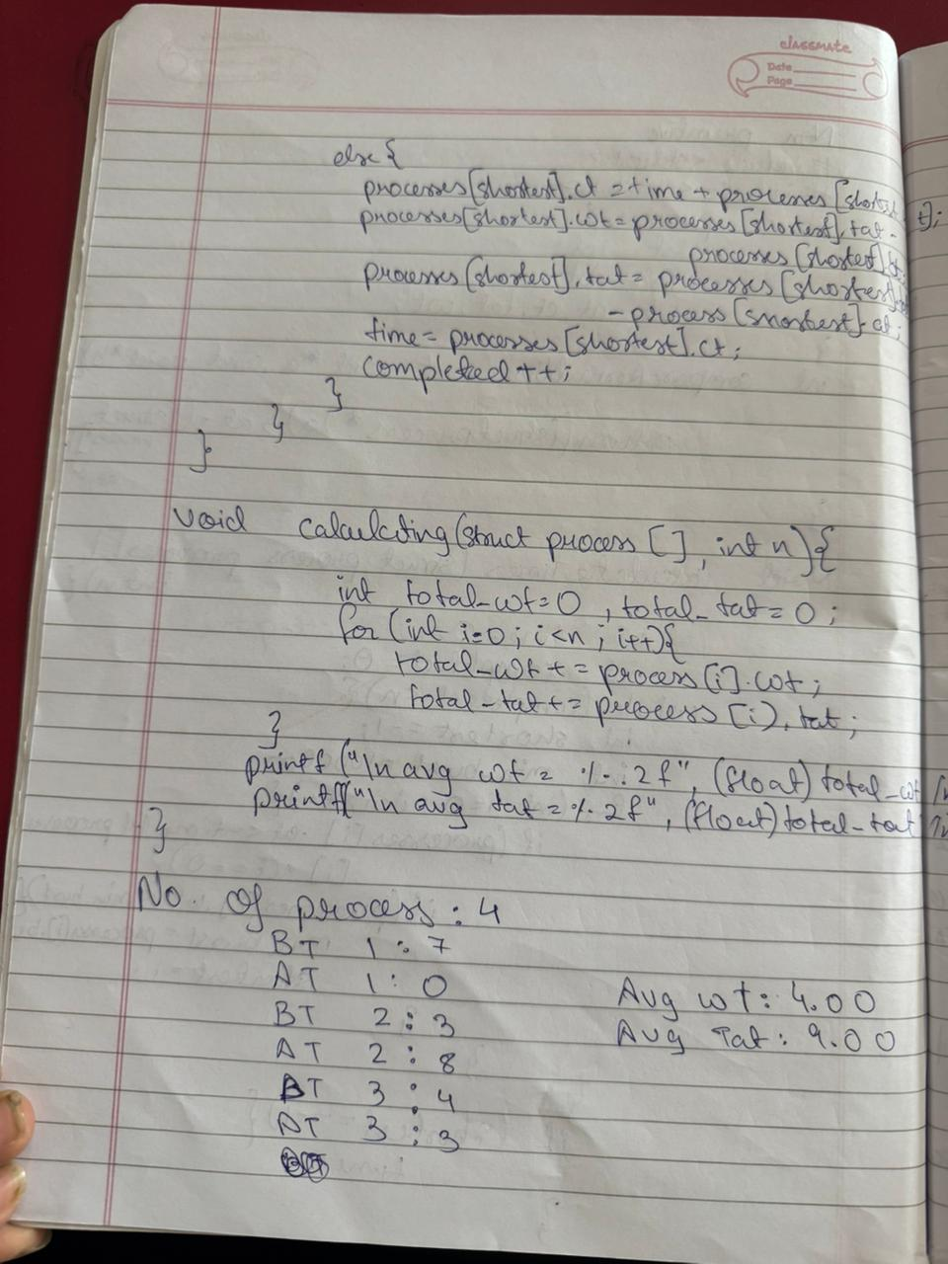

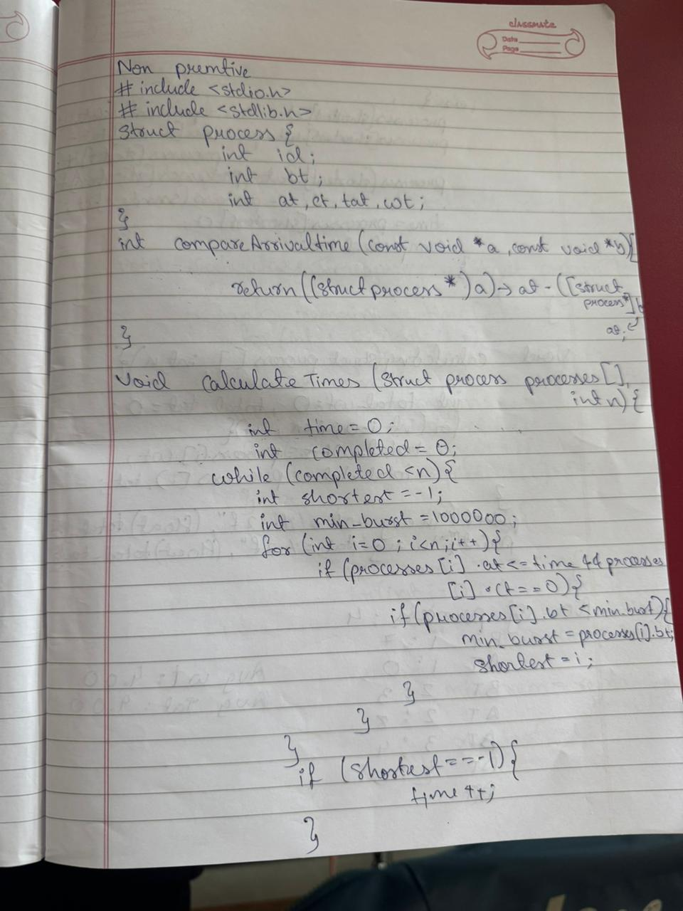

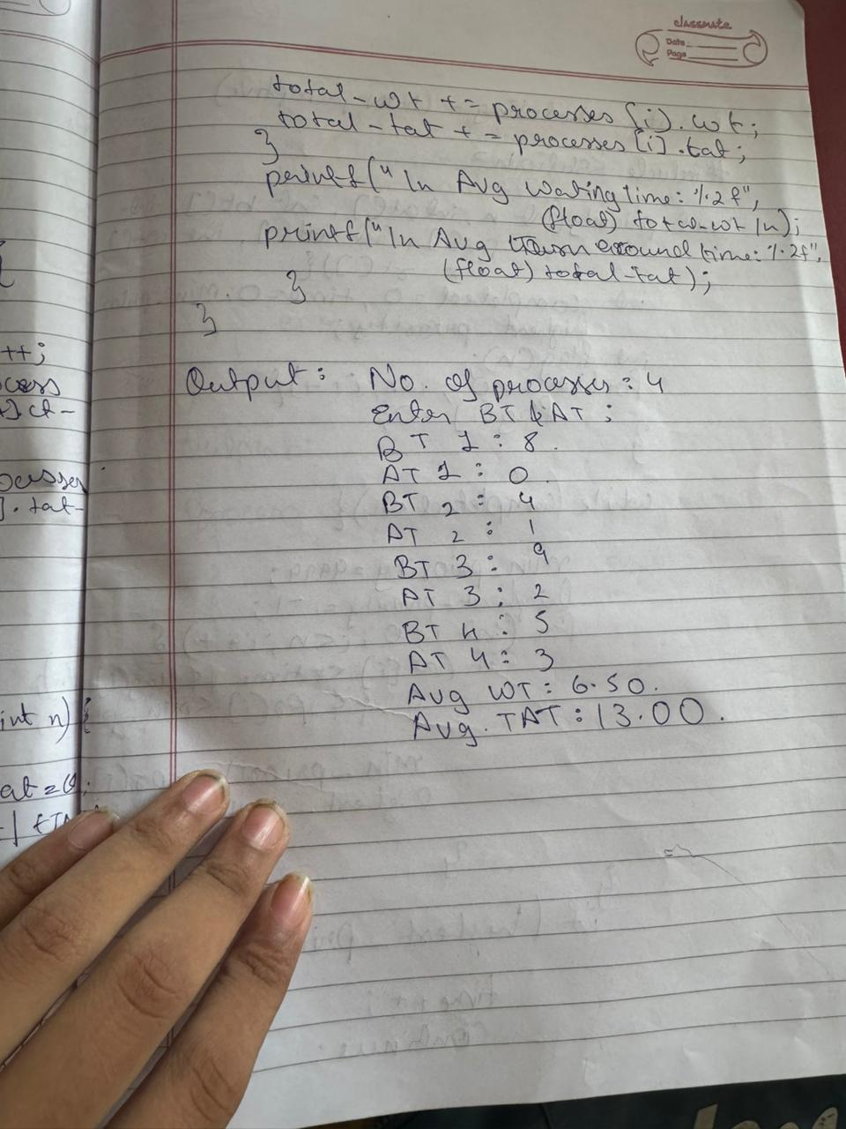Code

#include <stdio.h>

void preemptiveSJF(int n, int at[], int bt[], int ct[], int tat[], int wt[], int rt[])

{

int remaining_bt[n];

int completed = 0, time = 0, min_bt, shortest;

int flag[n];

for (int i = 0; i < n; i++)

{

remaining_bt[i] = bt[i];

flag[i] = 0;

}

while (completed < n)

{

min_bt = 9999;

shortest = -1;

for (int i = 0; i < n; i++)

{

if (at[i] <= time && remaining_bt[i] > 0 && remaining_bt[i] < min_bt && flag[i] == 0)

{

min_bt = remaining_bt[i];

shortest = i;

}

}

if (shortest == -1)

{

time++;

continue;

}

remaining_bt[shortest]--;

if (remaining_bt[shortest] == 0)

{

completed++;

flag[shortest] = 1;

ct[shortest] = time + 1;

tat[shortest] = ct[shortest] - at[shortest];

wt[shortest] = tat[shortest] - bt[shortest];

rt[shortest] = wt[shortest];

}

time++;

}

}

void displayTable(int n, int at[], int bt[], int ct[], int tat[], int wt[], int rt[])

{

printf("\nProcess\tAT\tBT\tCT\tTAT\tWT\tRT\n");

for (int i = 0; i < n; i++)

{

printf("%d\t%d\t%d\t%d\t%d\t%d\t%d\n", i + 1, at[i], bt[i], ct[i], tat[i], wt[i], rt[i]);

}

}

int main()

{

int n;

printf("Enter number of processes: ");

scanf("%d", &n);

int at[n], bt[n], ct[n], tat[n], wt[n], rt[n];

printf("Enter Arrival Time and Burst Time for each process:\n");

for (int i = 0; i < n; i++)

{

printf("Process %d - Arrival Time: ", i + 1);

scanf("%d", &at[i]);

printf("Process %d - Burst Time: ", i + 1);

scanf("%d", &bt[i]);

}

preemptiveSJF(n, at, bt, ct, tat, wt, rt);

displayTable(n, at, bt, ct, tat, wt, rt);

return 0;

}

Output:

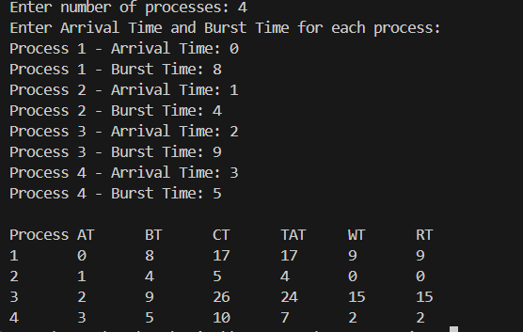

Program 2

Question

Write a C program to simulate the following CPU scheduling algorithm to find turnaround time and waiting time.

→ Priority (pre-emptive & Non-pre-emptive)

→ Round Robin (Experiment with different quantum sizes for RR algorithm)

=> Priority Scheduling (Non-preemptive):

Code

#include <stdio.h>

//non-preemptive

void priorityScheduling(int n, int at[], int bt[], int pr[], int ct[], int tat[], int wt[], int rt[]) {

int completed = 0, time = 0, min_priority, highest_priority;

int flag[n];

for (int i = 0; i < n; i++) {

flag[i] = 0;

}

while (completed < n) {

min_priority = 9999;

highest_priority = -1;

for (int i = 0; i < n; i++) {

if (at[i] <= time && flag[i] == 0 && pr[i] < min_priority) {

min_priority = pr[i];

highest_priority = i;

}

}

if (highest_priority == -1) {

time++;

continue;

}

time += bt[highest_priority];

flag[highest_priority] = 1;

ct[highest_priority] = time;

tat[highest_priority] = ct[highest_priority] - at[highest_priority];

wt[highest_priority] = tat[highest_priority] - bt[highest_priority];

rt[highest_priority] = wt[highest_priority];

completed++;

}

}

void displayTable(int n, int at[], int bt[], int pr[], int ct[], int tat[], int wt[], int rt[]) {

printf("\nProcess\tAT\tBT\tPriority\tCT\tTAT\tWT\tRT\n");

for (int i = 0; i < n; i++) {

printf("%d\t%d\t%d\t%d\t\t%d\t%d\t%d\t%d\n", i + 1, at[i], bt[i], pr[i], ct[i], tat[i], wt[i], rt[i]);

}

}

int main() {

int n;

printf("Enter number of processes: ");

scanf("%d", &n);

int at[n], bt[n], pr[n], ct[n], tat[n], wt[n], rt[n];

printf("Enter Arrival Time, Burst Time, and Priority for each process:\n");

for (int i = 0; i < n; i++) {

printf("Process %d - Arrival Time: ", i + 1);

scanf("%d", &at[i]);

printf("Process %d - Burst Time: ", i + 1);

scanf("%d", &bt[i]);

printf("Process %d - Priority: ", i + 1);

scanf("%d", &pr[i]);

}

priorityScheduling(n, at, bt, pr, ct, tat, wt, rt);

displayTable(n, at, bt, pr, ct, tat, wt, rt);

return 0;

}

Output: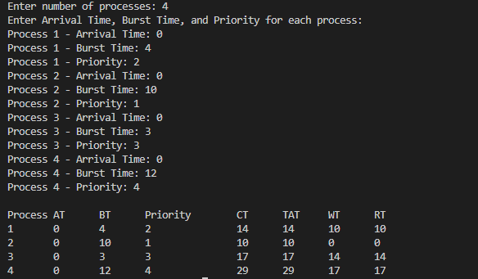

=> Priority Scheduling (Preemptive):

Code

#include <stdio.h>

struct Process {

int id, arrivalTime, burstTime, remainingTime, priority;

int waitingTime, turnaroundTime, completionTime;

};

int findHighestPriority(struct Process p[], int n, int currentTime) {

int highest = -1;

int highestPriority = 1e9;

for (int i = 0; i < n; i++) {

if (p[i].arrivalTime <= currentTime && p[i].remainingTime > 0) {

if (p[i].priority < highestPriority) {

highestPriority = p[i].priority;

highest = i;

}

}

}

return highest;

}

void priorityScheduling(struct Process p[], int n) {

int currentTime = 0, completed = 0;

float totalWaitingTime = 0, totalTurnaroundTime = 0;

for (int i = 0; i < n; i++) {

p[i].remainingTime = p[i].burstTime;

}

while (completed < n) {

int idx = findHighestPriority(p, n, currentTime);

if (idx == -1) {

currentTime++;

continue;

}

p[idx].remainingTime--;

currentTime++;

if (p[idx].remainingTime == 0) {

completed++;

p[idx].completionTime = currentTime;

p[idx].turnaroundTime = p[idx].completionTime - p[idx].arrivalTime;

p[idx].waitingTime = p[idx].turnaroundTime - p[idx].burstTime;

totalWaitingTime += p[idx].waitingTime;

totalTurnaroundTime += p[idx].turnaroundTime;

}

}

printf("\nProcess\tArrival\tBurst\tPriority\tCompletion\tTurnaround\tWaiting\n");

for (int i = 0; i < n; i++) {

printf("%d\t%d\t%d\t%d\t\t%d\t\t%d\t\t%d\n", p[i].id, p[i].arrivalTime, p[i].burstTime,

p[i].priority, p[i].completionTime, p[i].turnaroundTime, p[i].waitingTime);

}

printf("\nAverage Waiting Time: %.2f", totalWaitingTime / n);

printf("\nAverage Turnaround Time: %.2f\n", totalTurnaroundTime / n);

}

int main() {

int n;

printf("Enter number of processes: ");

scanf("%d",&n);

struct Process p[n];

printf("Enter Arrival Time, Burst Time, and Priority (lower number = higher priority) for each process:\n");

for (int i = 0; i < n; i++) {

p[i].id = i + 1;

printf("Process %d: ", p[i].id);

scanf("%d %d %d", &p[i].arrivalTime, &p[i].burstTime, &p[i].priority);

}

priorityScheduling(p, n);

return 0;

}

Output:

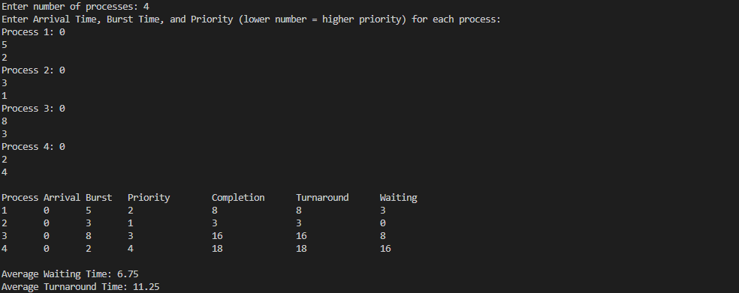

=> Round Robin:

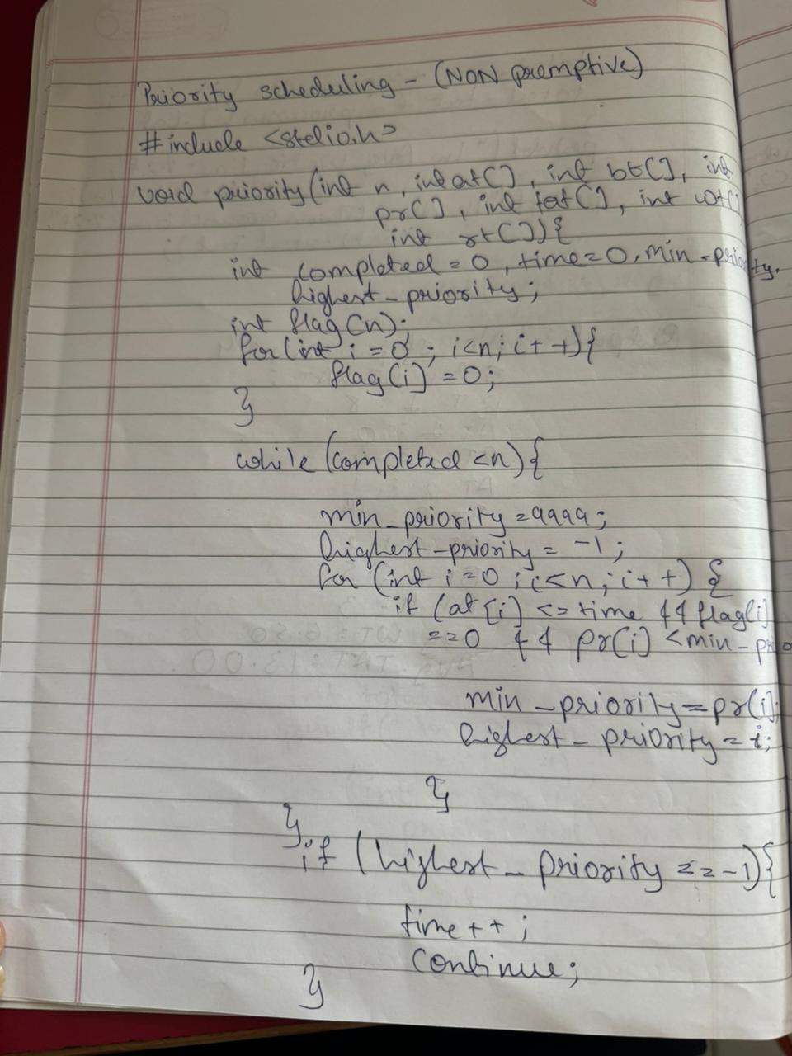

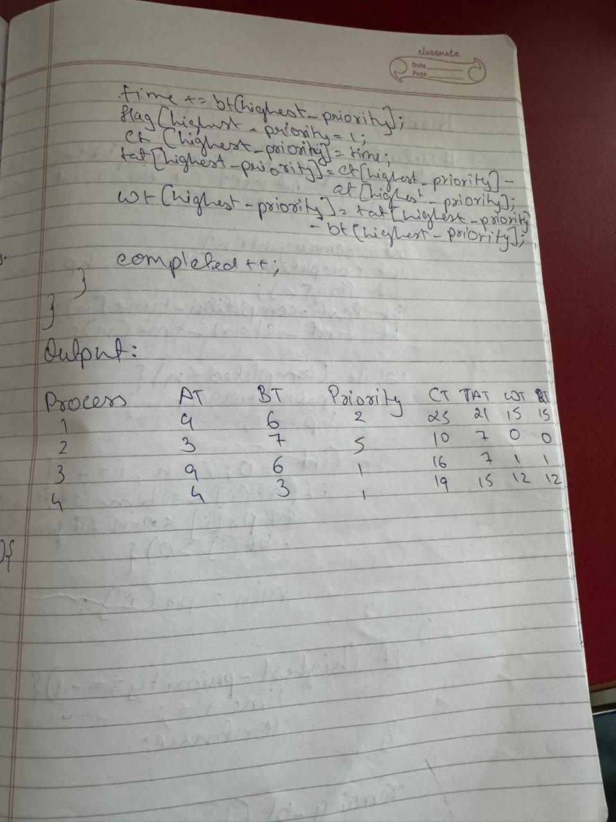

#include <stdio.h>

void findWaitingTime(int processes[], int n, int bt[], int wt[], int quantum) {

int rem_bt[n];

for (int i = 0; i < n; i++) {

rem_bt[i] = bt[i];

wt[i] = 0;

wt++;

}

int t = 0;

while (1) {

int done = 1;

for (int i = 0; i < n; i++) {

if (rem_bt[i] > 0) {

done = 0;

if (rem_bt[i] > quantum) {

rem_bt[i] -= quantum;

//++quantum;

t += quantum;

} else {

t += rem_bt[i];

wt[i] = t - bt[i];

rem_bt[i] = 0;

}

}

}

if (done) break;

}

}

void findTurnAroundTime(int processes[], int n, int bt[], int wt[], int tat[]) {

for (int i = 0; i < n; i++) {

tat[i] = bt[i] + wt[i];

}

}

void findAvgTime(int processes[], int n, int bt[], int quantum) {

int wt[n], tat[n];

findWaitingTime(processes, n, bt, wt, quantum);

findTurnAroundTime(processes, n, bt, wt, tat);

int total_wt = 0, total_tat = 0;

printf("\nProcess\tBurst Time\tWaiting Time\tTurnaround Time\n");

for (int i = 0; i < n; i++) {

total_wt += wt[i];

total_tat += tat[i];

printf("%d\t%d\t\t%d\t\t%d\n", processes[i], bt[i], wt[i], tat[i]);

}

printf("\nAverage Waiting Time: %.2f", (float)total_wt / n);

printf("\nAverage Turnaround Time: %.2f\n", (float)total_tat / n);

}

int main() {

int n, quantum;

printf("Enter number of processes: ");

scanf("%d", &n);

int processes[n];

int burst_time[n];

for (int i = 0; i < n; i++) {

processes[i] = i + 1;

printf("Enter burst time for process %d: ", i + 1);

scanf("%d", &burst_time[i]);

}

printf("Enter time quantum: ");

scanf("%d", &quantum);

findAvgTime(processes, n, burst_time, quantum);

return 0;

}

Output:

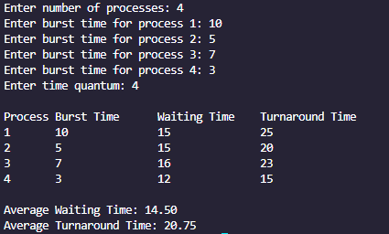

Program 3

Question

Write a C program to simulate multi-level queue scheduling algorithm considering the following scenario. All the processes in the system are divided into two categories – system processes and user processes. System processes are to be given higher priority than user processes. Use FCFS scheduling for the processes in each queue.

=> Multilevel queue Scheduling

Code

#include <stdio.h>

#define TIME_QUANTUM 2

typedef struct {

int pid, burst_time, arrival_time, queue;

int waiting_time, turnaround_time, response_time, remaining_time;

} Process;

void sort_by_arrival(Process p[], int n) {

Process temp;

for (int i = 0; i < n - 1; i++) {

for (int j = i + 1; j < n; j++) {

if (p[i].arrival_time > p[j].arrival_time) {

temp = p[i];

p[i] = p[j];

p[j] = temp;

}

}

}

}

void round_robin(Process p[], int n, int *time) {

int done, i;

do {

done = 1;

for (i = 0; i < n; i++) {

if (p[i].remaining_time > 0) {

done = 0;

if (p[i].remaining_time > TIME_QUANTUM) {

*time += TIME_QUANTUM;

p[i].remaining_time -= TIME_QUANTUM;

} else {

*time += p[i].remaining_time;

p[i].waiting_time = *time - p[i].arrival_time - p[i].burst_time;

p[i].turnaround_time = p[i].waiting_time + p[i].burst_time;

p[i].response_time = p[i].waiting_time;

p[i].remaining_time = 0;

}

}

}

} while (!done);

}

void fcfs(Process p[], int n, int *time) {

for (int i = 0; i < n; i++) {

if (*time < p[i].arrival_time)

*time = p[i].arrival_time;

p[i].waiting_time = *time - p[i].arrival_time;

p[i].turnaround_time = p[i].waiting_time + p[i].burst_time;

p[i].response_time = p[i].waiting_time;

*time += p[i].burst_time;

}

}

int main() {

int n, i, time = 0;

printf("Enter number of processes: ");

scanf("%d", &n);

Process p[n], system_processes[n], user_processes[n];

int sys_count = 0, user_count = 0;

for (i = 0; i < n; i++) {

printf("Enter Burst Time, Arrival Time and Queue of P%d: ", i + 1);

p[i].pid = i + 1;

scanf("%d %d %d", &p[i].burst_time, &p[i].arrival_time, &p[i].queue);

p[i].remaining_time = p[i].burst_time;

if (p[i].queue == 0)

system_processes[sys_count++] = p[i];

else

user_processes[user_count++] = p[i];

}

sort_by_arrival(system_processes, sys_count);

sort_by_arrival(user_processes, user_count);

printf("\nQueue 1 is System Process\nQueue 2 is User Process\n");

round_robin(system_processes, sys_count, &time);

fcfs(user_processes, user_count, &time);

Process final_list[n];

int index = 0;

for (i = 0; i < sys_count; i++)

final_list[index++] = system_processes[i];

for (i = 0; i < user_count; i++)

final_list[index++] = user_processes[i];

printf("\nProcess\tWaiting Time\tTurn Around Time\tResponse Time\n");

float avg_wt = 0, avg_tat = 0, avg_rt = 0;

for (i = 0; i < n; i++) {

printf("%d\t%d\t\t%d\t\t\t%d\n", final_list[i].pid, final_list[i].waiting_time, final_list[i].turnaround_time, final_list[i].response_time);

avg_wt += final_list[i].waiting_time;

avg_tat += final_list[i].turnaround_time;

avg_rt += final_list[i].response_time;

}

avg_wt /= n;

avg_tat /= n;

avg_rt /= n;

float throughput = (float)n / time;

printf("\nAverage Waiting Time: %.2f", avg_wt);

printf("\nAverage Turn Around Time: %.2f", avg_tat);

printf("\nAverage Response Time: %.2f", avg_rt);

printf("\nThroughput: %.2f", throughput);

return 0;

}

Output:

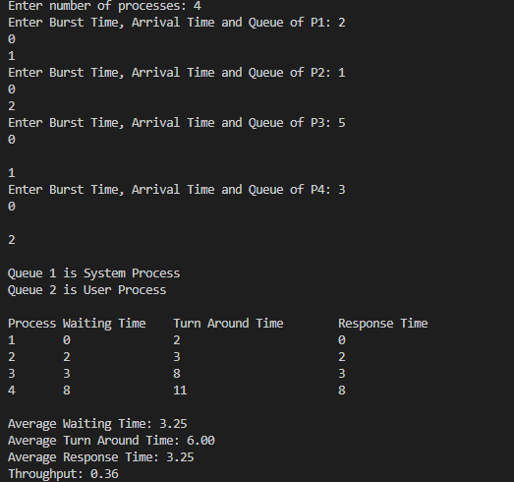

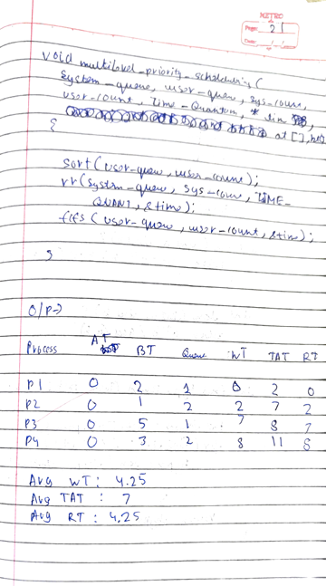

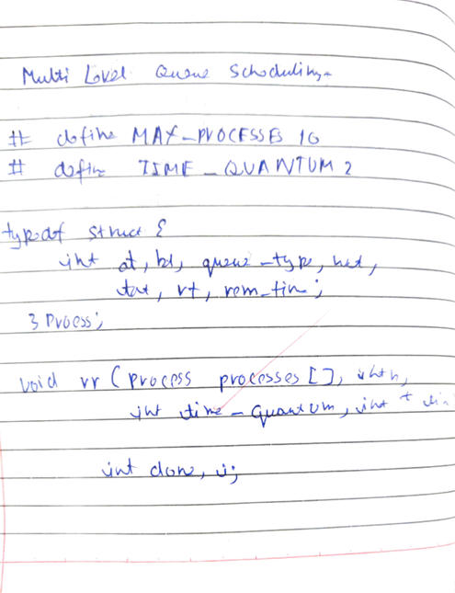

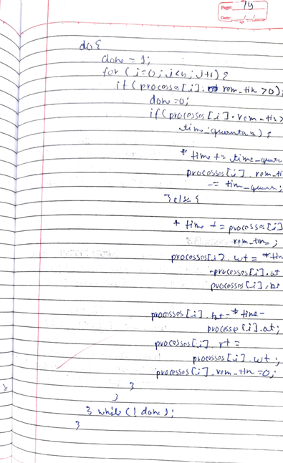  
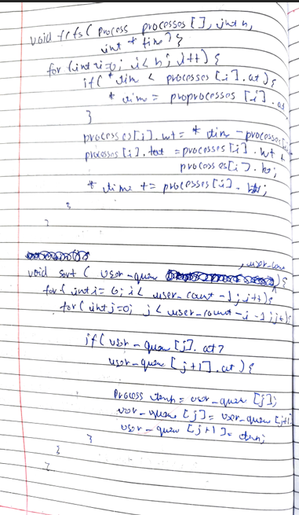



Program 4

Question

Write a C program to simulate Real-Time CPU Scheduling algorithms:

-> Rate- Monotonic

-> Earliest-deadline First

-> Proportional scheduling

=> Rate Monotonic Scheduling

Code

#include <stdio.h>

#include <stdlib.h>

typedef struct {

int id;

int period;

int execution_time;

int next_deadline;

int executed;

} Task;

int compare_tasks(const void *a, const void *b) {

return ((Task *)a)->period - ((Task *)b)->period;

}

void rate_monotonic_scheduling(Task tasks[], int num_tasks, int total_time) {

qsort(tasks, num_tasks, sizeof(Task), compare_tasks);

/*

for(int i = 0; i < num_tasks; i++)

printf("Task %d: %d %d\n", tasks[i].id, tasks[i].execution_time, tasks[i].period);

*/

for (int i = 0; i < num_tasks; i++)

tasks[i].next_deadline = tasks[i].period;

printf("Time\t");

for (int i = 0; i < num_tasks; i++)

printf("Task %d\t", tasks[i].id);

printf("\n");

for (int current_time = 0; current_time < total_time; current_time++)

{

printf("%d\t", current_time);

int executed_task = -1;

for (int i = 0; i < num_tasks; i++)

{

if (current_time % tasks[i].period == 0)

{

tasks[i].next_deadline = current_time + tasks[i].period;

tasks[i].executed = 0;

}

if (current_time < tasks[i].next_deadline)

{

if(tasks[i].executed < tasks[i].execution_time)

{

executed_task = i;

tasks[i].executed++;

break;

}

}

}

if (executed_task != -1)

{

for (int i = 0; i < num_tasks; i++)

{

if (i == executed_task) {

printf("Exec\t");

} else {

printf("\t");

}

}

} else {

for (int i = 0; i < num_tasks; i++) {

printf("\t");

}

}

printf("\n");

}

}

int main() {

Task tasks[] = {

{1, 20, 3},

{2, 5, 2},

{3, 10, 2}

};

int num_tasks = sizeof(tasks) / sizeof(tasks[0]);

int total_time = 20;

rate_monotonic_scheduling(tasks, num_tasks, total_time);

return 0;

}

Output:

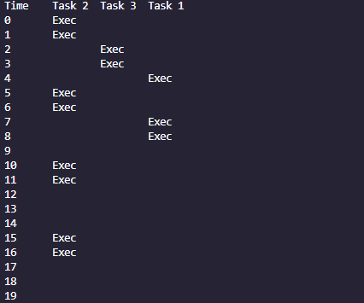

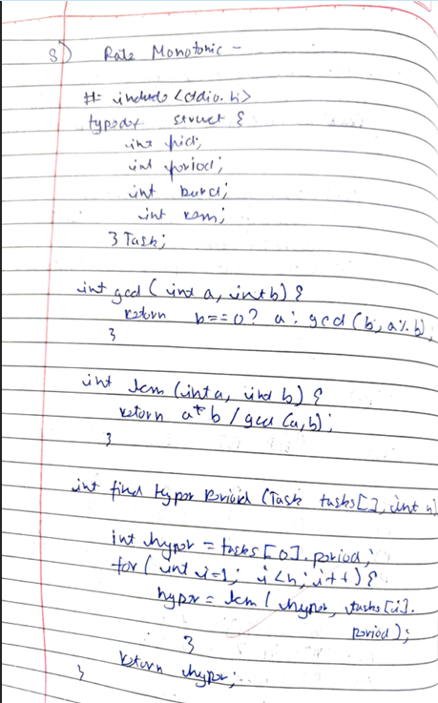

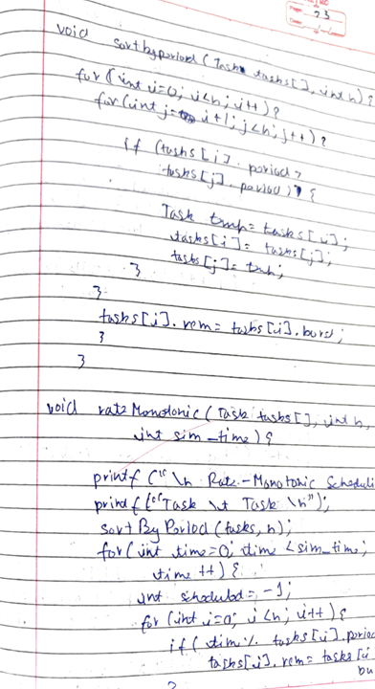

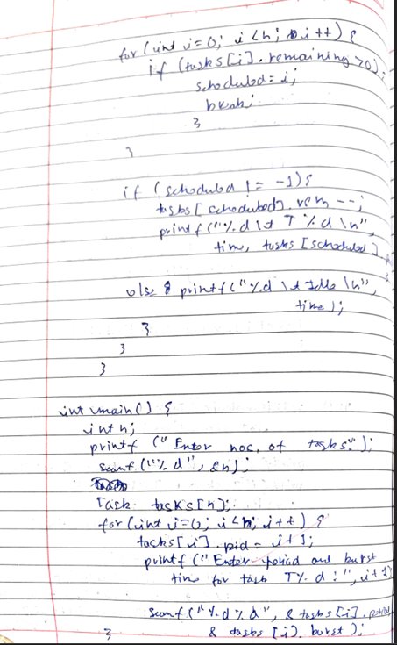

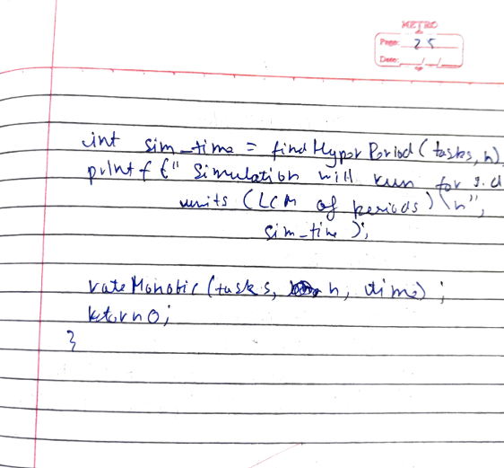

=> Earliest Deadline First

Code

#include <stdio.h>

#include <stdlib.h>

typedef struct {

int id;

int period;

int execution_time;

int deadline;

int executed;

} Task;

int compare_tasks(const void *a, const void *b) {

return ((Task *)a)->deadline - ((Task *)b)->deadline;

}

void earliest_deadline_first_scheduling(Task tasks[], int num_tasks, int total_time) {

printf("Time\t");

for (int i = 0; i < num_tasks; i++)

printf("Task %d\t", tasks[i].id);

printf("\n");

for (int current_time = 0; current_time < total_time; current_time++) {

printf("%d\t", current_time);

int executed_task = -1;

for (int i = 0; i < num_tasks; i++) {

if (current_time % tasks[i].period == 0) {

tasks[i].deadline = current_time + tasks[i].period;

tasks[i].executed = 0;

}

}

qsort(tasks, num_tasks, sizeof(Task), compare_tasks);

for (int i = 0; i < num_tasks; i++) {

if (current_time < tasks[i].deadline && tasks[i].executed < tasks[i].execution_time) {

executed_task = i;

tasks[i].executed++;

break;

}

}

if (executed_task != -1) {

for (int i = 0; i < num_tasks; i++) {

if (i == executed_task) {

printf("Exec\t");

} else {

printf("\t");

}

}

} else {

for (int i = 0; i < num_tasks; i++) {

printf("\t");

}

}

printf("\n");

}

}

int main() {

Task tasks[] = {

{1, 20, 3, 20, 0},

{2, 5, 2, 5, 0},

{3, 10, 2, 10, 0} //task

};

int num_tasks = sizeof(tasks) / sizeof(tasks[0]);

int total_time = 20;

earliest_deadline_first_scheduling(tasks, num_tasks, total_time);

return 0;

}

Output:

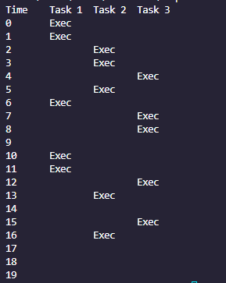

Program 5

Question

Write a C program to simulate producer-consumer problem using semaphores

=> Producer Consumer

Code

#include <stdio.h>

int x = 1, mutex = 1, full = 0, empty = 3;

void wait(int *S)

{

(*S)--;

}

void signal(int *S)

{

(*S)++;

}

void producer()

{

wait(&mutex);

if (empty > 0)

{

wait(&empty);

signal(&full);

printf("Item produced: %d\n", x++);

} else {

printf("Buffer is Full\n");

}

signal(&mutex);

}

void consumer() {

wait(&mutex);

if (full > 0) {

wait(&full);

signal(&empty);

printf("Item Consumed: %d\n", --x);

} else {

printf("Buffer is Empty\n");

}

signal(&mutex);

}

int main() {

int ch;

printf("1. Produce\n2. Consume\n3. Exit\n");

while (1) {

printf("Enter Choice: ");

scanf("%d", &ch);

switch (ch) {

case 1: producer(); break;

case 2: consumer(); break;

default: return 0;

}

}

}

Output:

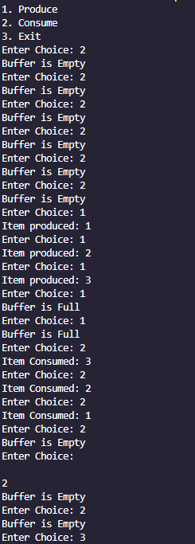

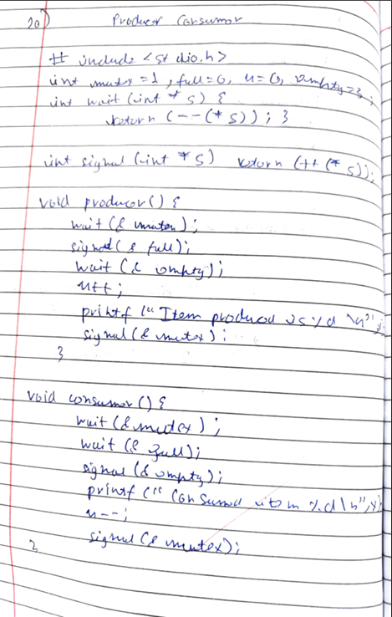

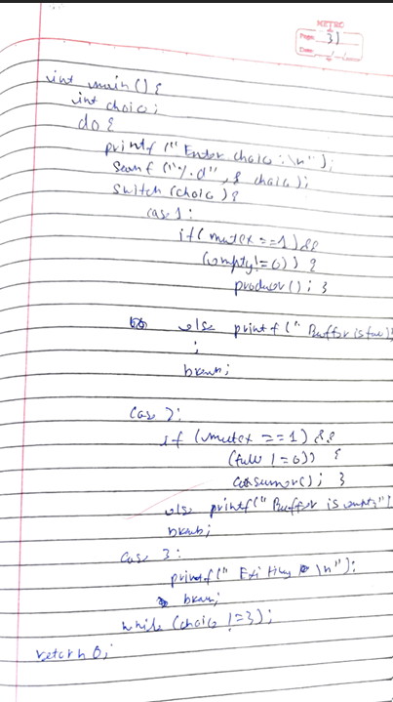

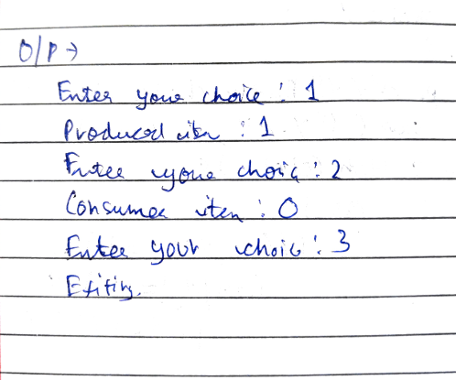

Program 6

Question

Write a C program to simulate the concept of Dining Philosophers problem.

=> Dining Philosophers

Code

//PTHRED AND SEMAPHORE LIBRARY ONLY WORK IN CODEBLOCKS, NOT VSC

#include <pthread.h>

#include <semaphore.h>

#include <stdio.h>

#include <unistd.h>

#define N 5

#define THINKING 2

#define HUNGRY 1

#define EATING 0

#define LEFT (phnum + 4) % N

#define RIGHT (phnum + 1) % N

int state[N];

int phil[N] = {0, 1, 2, 3, 4};

sem_t mutex;

sem_t S[N];

void test(int phnum) {

if (state[phnum] == HUNGRY && state[LEFT] != EATING && state[RIGHT] != EATING) {

state[phnum] = EATING;

sleep(2);

printf("Philosopher %d takes fork %d and %d\n", phnum + 1, LEFT + 1, phnum + 1);

printf("Philosopher %d is Eating\n", phnum + 1);

sem_post(&S[phnum]);

}

}

void take_fork(int phnum) {

sem_wait(&mutex);

state[phnum] = HUNGRY;

printf("Philosopher %d is Hungry\n", phnum + 1);

test(phnum);

sem_post(&mutex);

sem_wait(&S[phnum]);

sleep(1);

}

void put_fork(int phnum) {

sem_wait(&mutex);

state[phnum] = THINKING;

printf("Philosopher %d putting fork %d and %d down\n", phnum + 1, LEFT + 1, phnum + 1);

printf("Philosopher %d is thinking\n", phnum + 1);

test(LEFT);

test(RIGHT);

sem_post(&mutex);

}

void* philosopher(void* num) {

while (1) {

int* i = (int*)num;

sleep(1);

take_fork(*i);

sleep(0);

put_fork(*i);

}

}

int main() {

int i;

pthread_t thread_id[N];

sem_init(&mutex, 0, 1);

for (i = 0; i < N; i++) {

sem_init(&S[i], 0, 0);

}

for (i = 0; i < N; i++) {

pthread_create(&thread_id[i], NULL, philosopher, (void*)&phil[i]);

printf("Philosopher %d is thinking\n", i + 1);

}

for (i = 0; i < N; i++) {

pthread_join(thread_id[i], NULL);

}

return 0;

}

Output:

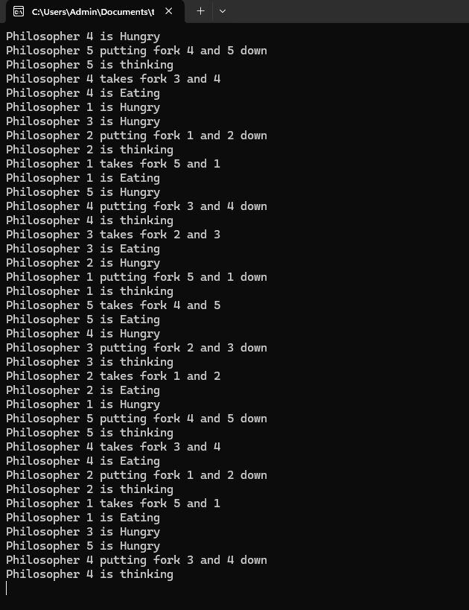

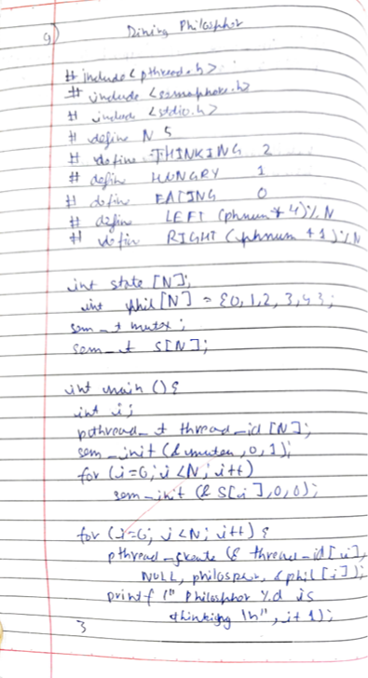

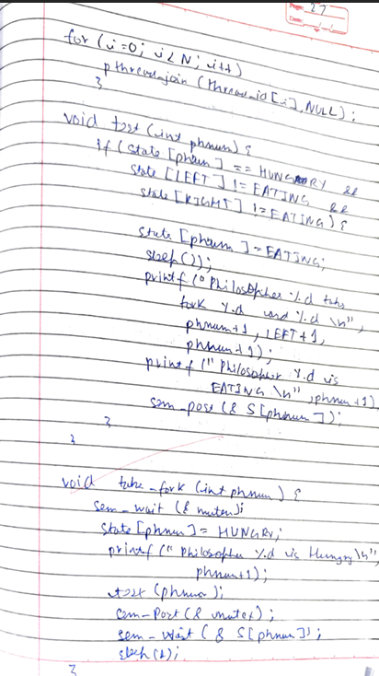

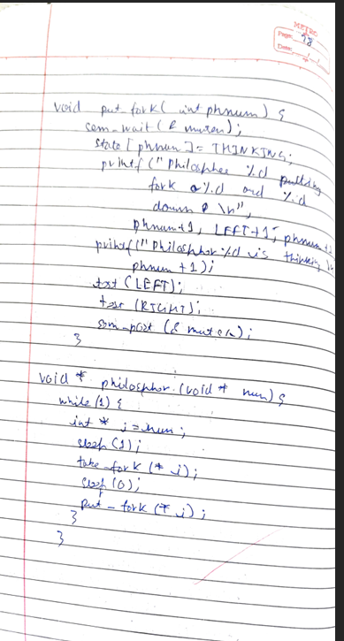

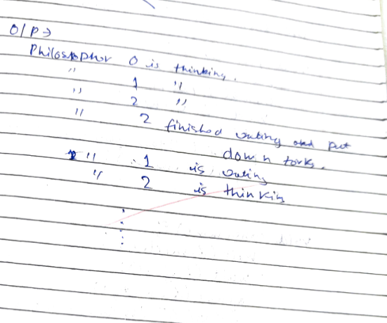

Program 7

Question

Write a C program to simulate Bankers algorithm for the purpose of deadlock avoidance.

=> Banker’s Algorithm / Deadlock Avoidance

Code

#include <stdio.h>

#include <stdlib.h>

int condition(int **need, int *work, int i, int m)

{

for (int j = 0; j < m; j++)

{

if (need[i][j] > work[j])

return 0;

}

return 1;

}

int safety(int m, int n, int **allocated, int **max, int *available, int *sequence)

{

// Need Matrix

int **need = (int**) malloc(n * sizeof(int*));

for (int i = 0; i < n; i++)

{

need[i] = (int*) malloc(m * sizeof(int));

for (int j = 0; j < m; j++)

{

need[i][j] = max[i][j] - allocated[i][j];

}

}

// Work array

int *work = (int*) malloc(m * sizeof(int));

for (int i = 0; i < m; i++)

{

work[i] = available[i];

}

// Finish array

int *finish = (int*) malloc(n * sizeof(int));

for (int i = 0; i < n; i++)

{

finish[i] = 0;

}

int safeIndex = 0;

int changed;

do {

changed = 0;

for (int i = 0; i < n; i++)

{

if (!finish[i] && condition(need, work, i, m))

{

for (int j = 0; j < m; j++)

{

work[j] += allocated[i][j];

}

finish[i] = 1;

sequence[safeIndex++] = i;

changed = 1;

}

}

} while (changed);

for (int i = 0; i < n; i++)

{

if (!finish[i])

{

return 0;

}

}

return 1;

}

int main()

{

int n, m;

printf("Enter number of processes and resources (n x m order): ");

scanf("%d",&n);

scanf("%d",&m);

// Allocation Matrix

printf("Enter Allocation Matrix:\n");

int **allocated = (int **) malloc(n * sizeof(int*));

for (int i = 0; i < n; i++)

{

allocated[i] = (int*) malloc(m * sizeof(int));

for (int j = 0; j < m; j++)

{

scanf("%d", &allocated[i][j]);

}

}

// Max Matrix

printf("Enter Max Matrix:\n");

int **max = (int **) malloc(n * sizeof(int*));

for (int i = 0; i < n; i++)

{

max[i] = (int*) malloc(m * sizeof(int));

for (int j = 0; j < m; j++)

{

scanf("%d", &max[i][j]);

}

}

// Available Matrix

printf("Enter Available matrix:\n");

int *available = (int *) malloc(m * sizeof(int));

for (int i = 0; i < m; i++)

{

scanf("%d", &available[i]);

}

// Sequence Matrix

int *sequence = (int *) malloc(n * sizeof(int));

int safe = safety(m, n, allocated, max, available, sequence);

if (safe)

{

printf("System is in a Safe State.\nSafe Sequence: ");

for (int i = 0; i < n; i++)

{

printf("P%d\t", sequence[i]);

}

printf("\n");

}

else

{

printf("System is not in a Safe State.\n");

}

return 0;

}

Output:

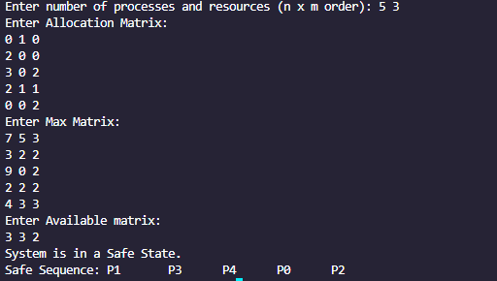

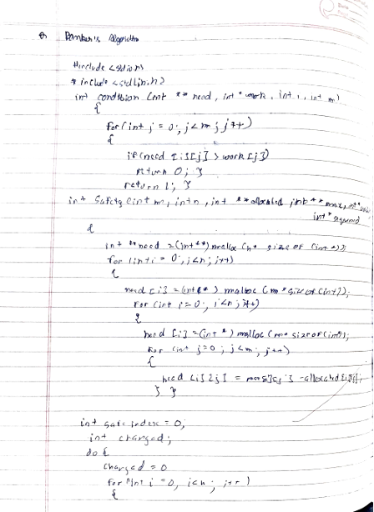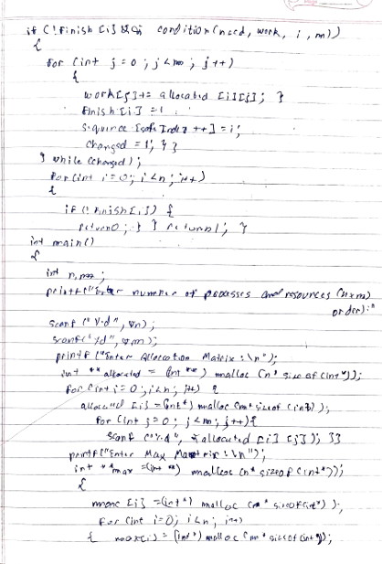

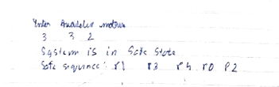

Program 8

Question

Write a C program to simulate deadlock detection

=> Deadlock Detection

Code

#include <stdio.h>

#include <stdbool.h>

#define P 5

#define R 3

int main() {

int finish[P] = {0};

int work[R];

int need[P][R] = {

{7, 5, 3},

{3, 2, 2},

{9, 0, 2},

{2, 2, 2},

{4, 3, 3}

};

int allocation[P][R] = {

{0, 1, 0},

{2, 0, 0},

{3, 0, 2},

{2, 1, 1},

{0, 0, 2}

};

int available[R] = {3, 3, 2};

for (int i = 0; i < R; i++) {

work[i] = available[i];

}

bool deadlock = false;

int count = 0;

while (count < P) {

bool found = false;

for (int p = 0; p < P; p++) {

if (finish[p] == 0) {

bool canFinish = true;

for (int r = 0; r < R; r++) {

if (need[p][r] - allocation[p][r] > work[r]) {

canFinish = false;

break;

}

}

if (canFinish) {

for (int r = 0; r < R; r++) {

work[r] += allocation[p][r];

}

printf("Process %d can finish.\n", p);

finish[p] = 1;

found = true;

count++;

}

}

}

if (!found) {

deadlock = true;

break;

}

}

if (deadlock) {

printf("System is in a deadlock state.\n");

} else {

printf("System is not in a deadlock state.\n");

}

return 0;

}

Output:

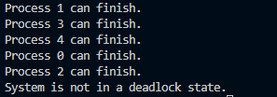

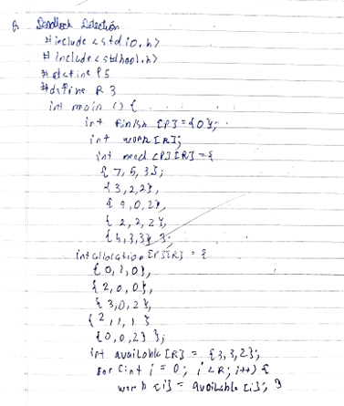

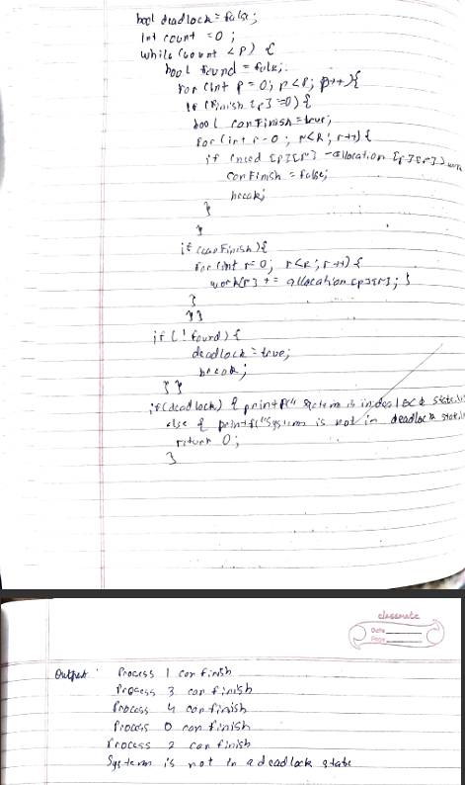

Program 9

Question

Write a C program to simulate the following contiguous memory allocation techniques a) Worst-fit

1. Best-fit
2. First-fit

=> Best fit, worst fit, first fit

Code

#include <stdio.h>

struct Block {

int block_no;

int block_size;

int is_free;

};

struct File {

int file_no;

int file_size;

};

void bestFit(struct Block blocks[], int n_blocks, struct File files[], int n_files) {

printf("Memory Management Scheme - Best Fit\n");

printf("File_no:\tFile_size:\tBlock_no:\tBlock_size:\tFragment\n");

for (int i = 0; i < n_files; i++) {

int best_fit_block = -1;

int min_fragment = 10000; // Initialize with a large value

for (int j = 0; j < n_blocks; j++) {

if (blocks[j].is_free && blocks[j].block_size >= files[i].file_size) {

int fragment = blocks[j].block_size - files[i].file_size;

if (fragment < min_fragment) {

min_fragment = fragment;

best_fit_block = j;

}

}

}

if (best_fit_block != -1) {

blocks[best_fit_block].is_free = 0;

printf("%d\t\t%d\t\t%d\t\t%d\t\t%d\n", files[i].file_no, files[i].file_size,

blocks[best_fit_block].block_no, blocks[best_fit_block].block_size, min_fragment);

}

}

}

void firstFit(struct Block blocks[], int n_blocks, struct File files[], int n_files) {

printf("Memory Management Scheme - First Fit\n");

printf("File_no:\tFile_size:\tBlock_no:\tBlock_size:\tFragment\n");

for (int i = 0; i < n_files; i++) {

int found = 0;

for (int j = 0; j < n_blocks; j++) {

if (blocks[j].is_free && blocks[j].block_size >= files[i].file_size) {

blocks[j].is_free = 0;

int fragment = blocks[j].block_size - files[i].file_size;

printf("%d\t\t%d\t\t%d\t\t%d\t\t%d\n", files[i].file_no, files[i].file_size,

blocks[j].block_no, blocks[j].block_size, fragment);

found = 1;

break;

}

}

if (!found) {

printf("No suitable block found for File %d\n", files[i].file_no);

}

}

}

void worstFit(struct Block blocks[], int n_blocks, struct File files[], int n_files) {

printf("Memory Management Scheme - Worst Fit\n");

printf("File_no:\tFile_size:\tBlock_no:\tBlock_size:\tFragment\n");

for (int i = 0; i < n_files; i++) {

int worst_fit_block = -1;

int max_fragment = -1; // Initialize with a small value

for (int j = 0; j < n_blocks; j++) {

if (blocks[j].is_free && blocks[j].block_size >= files[i].file_size) {

int fragment = blocks[j].block_size - files[i].file_size;

if (fragment > max_fragment) {

max_fragment = fragment;

worst_fit_block = j;

}

}

}

if (worst_fit_block != -1) {

blocks[worst_fit_block].is_free = 0;

printf("%d\t\t%d\t\t%d\t\t%d\t\t%d\n", files[i].file_no, files[i].file_size,

blocks[worst_fit_block].block_no, blocks[worst_fit_block].block_size, max_fragment);

}

}

}

int main() {

int n_blocks, n_files;

printf("Enter the number of blocks: ");

scanf("%d", &n_blocks);

printf("Enter the number of files: ");

scanf("%d", &n_files);

struct Block blocks[n_blocks];

for (int i = 0; i < n_blocks; i++) {

blocks[i].block_no = i + 1;

printf("Enter the size of block %d: ", i + 1);

scanf("%d", &blocks[i].block_size);

blocks[i].is_free = 1;

}

struct File files[n_files];

for (int i = 0; i < n_files; i++) {

files[i].file_no = i + 1;

printf("Enter the size of file %d: ", i + 1);

scanf("%d", &files[i].file_size);

}

while(1) {

int choice;

printf("Choose Memory Management Scheme:\n");

printf("1. Best Fit\n");

printf("2. First Fit\n");

printf("3. Worst Fit\n");

printf("[ANY KEY]. Exit\n");

printf("Enter your choice: ");

scanf("%d", &choice);

// Reset blocks for allocation scheme

for (int i = 0; i < n_blocks; i++) {

blocks[i].is_free = 1;

}

switch (choice) {

case 1:

bestFit(blocks, n_blocks, files, n_files);

break;

case 2:

firstFit(blocks, n_blocks, files, n_files);

break;

case 3:

worstFit(blocks, n_blocks, files, n_files);

break;

default:

printf("Closing...");

return 0;

} }

return 0;

}

Output:

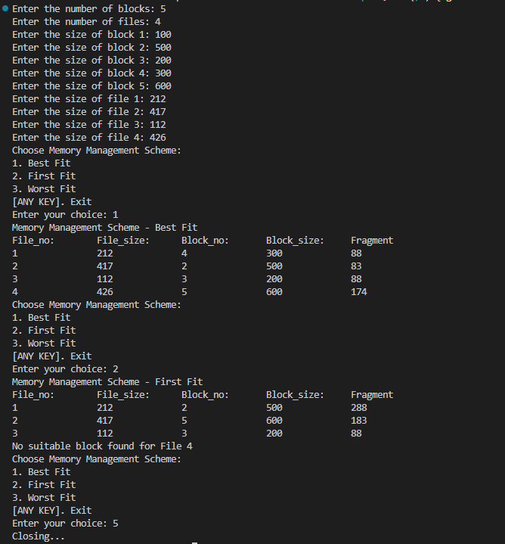

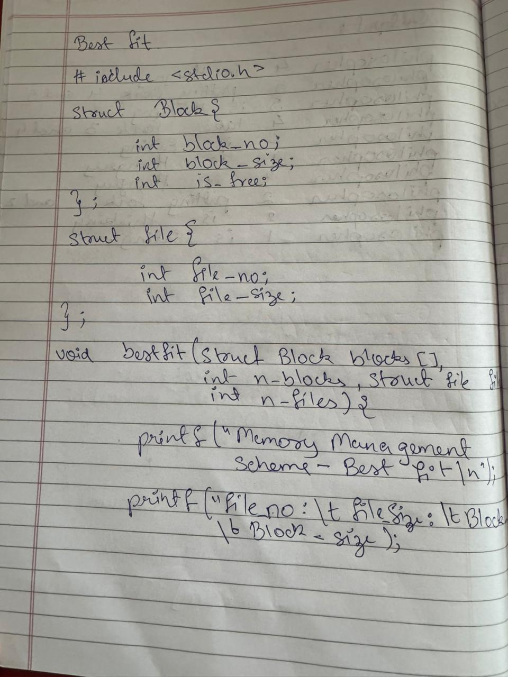

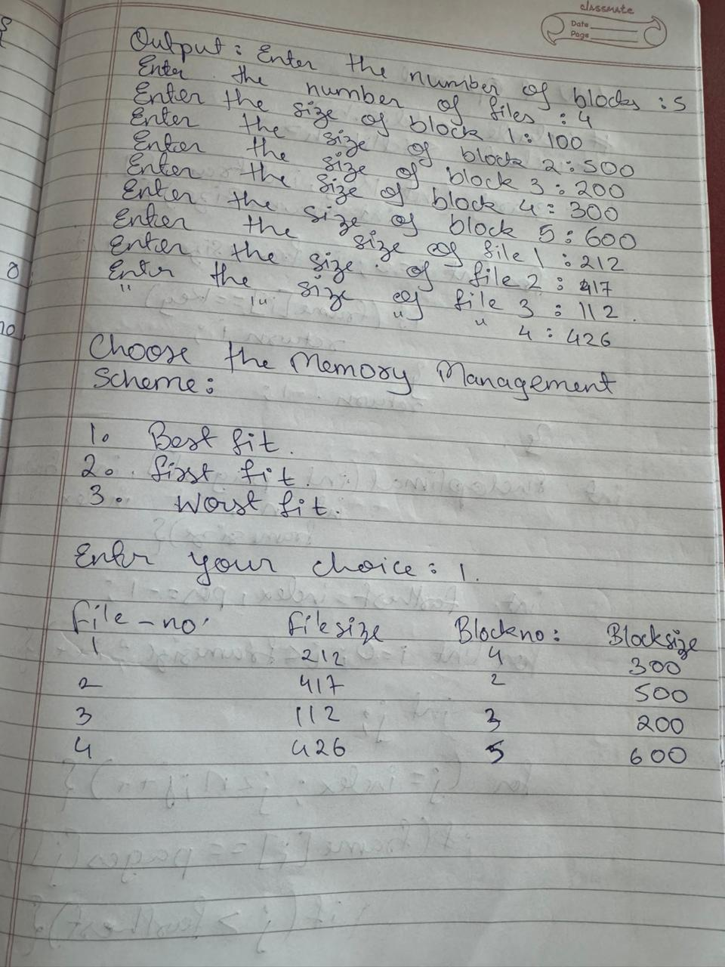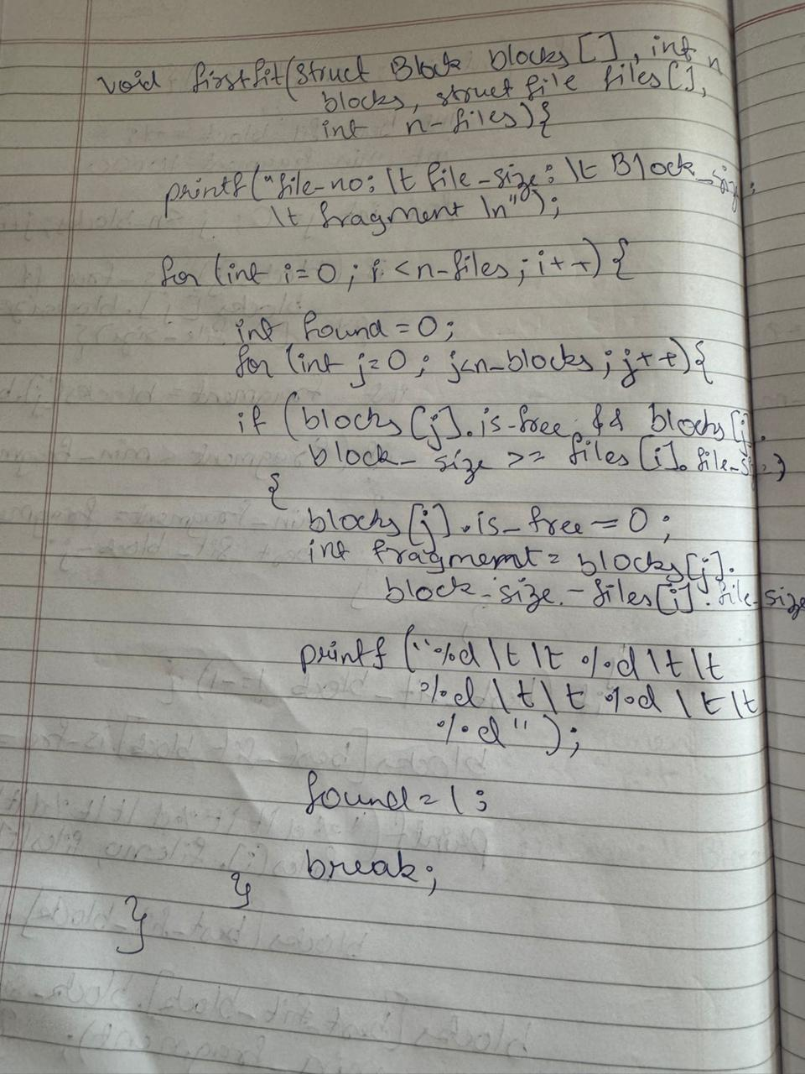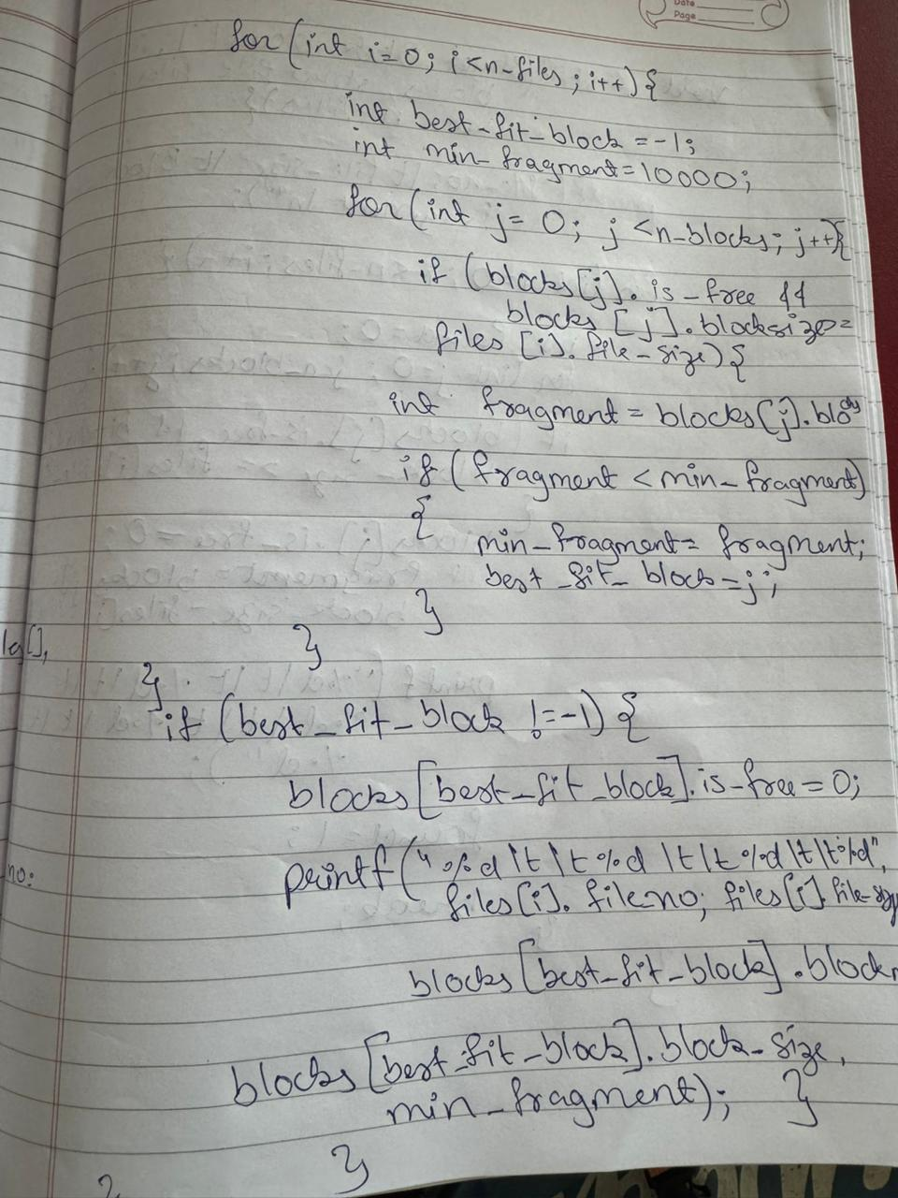Program 10

Question

Write a C program to simulate page replacement algorithms a) FIFO

1. LRU
2. Optimal

=> LRU & Optimal

Code

#include <stdio.h>

#include <stdlib.h>

int search(int key, int frame[], int frameSize) {

for (int i = 0; i < frameSize; i++) {

if (frame[i] == key)

return i;

}

return -1;

}

int findOptimal(int pages[], int frame[], int n, int index, int frameSize) {

int farthest = index, pos = -1;

for (int i = 0; i < frameSize; i++) {

int j;

for (j = index; j < n; j++) {

if (frame[i] == pages[j]) {

if (j > farthest) {

farthest = j;

pos = i;

}

break;

}

}

if (j == n)

return i;

}

return (pos == -1) ? 0 : pos;

}

void simulateFIFO(int pages[], int n, int frameSize) {

int frame[frameSize], front = 0, count = 0, hits = 0;

for (int i = 0; i < frameSize; i++)

frame[i] = -1;

for (int i = 0; i < n; i++) {

if (search(pages[i], frame, frameSize) == -1) {

frame[front] = pages[i];

front = (front + 1) % frameSize;

count++;

} else {

hits++;

}

}

printf("FIFO Page Faults: %d, Page Hits: %d\n", count, hits);

}

void simulateLRU(int pages[], int n, int frameSize) {

int frame[frameSize], time[frameSize], count = 0, hits = 0;

for (int i = 0; i < frameSize; i++) {

frame[i] = -1;

time[i] = 0;

}

for (int i = 0; i < n; i++) {

int pos = search(pages[i], frame, frameSize);

if (pos == -1) {

int least = 0;

for (int j = 1; j < frameSize; j++) {

if (time[j] < time[least])

least = j;

}

frame[least] = pages[i];

time[least] = i;

count++;

} else {

hits++;

time[pos] = i;

}

}

printf("LRU Page Faults: %d, Page Hits: %d\n", count, hits);

}

void simulateOptimal(int pages[], int n, int frameSize) {

int frame[frameSize], count = 0, hits = 0;

for (int i = 0; i < frameSize; i++)

frame[i] = -1;

for (int i = 0; i < n; i++) {

if (search(pages[i], frame, frameSize) == -1) {

int index = -1;

for (int j = 0; j < frameSize; j++) {

if (frame[j] == -1) {

index = j;

break;

}

}

if (index != -1) {

frame[index] = pages[i];

} else {

int replaceIndex = findOptimal(pages, frame, n, i + 1, frameSize);

frame[replaceIndex] = pages[i];

}

count++;

} else {

hits++;

}

}

printf("Optimal Page Faults: %d, Page Hits: %d\n", count, hits);

}

int main() {

int n, frameSize;

printf("Enter the size of the pages: ");

scanf("%d", &n);

int pages[n];

printf("Enter the page strings: ");

for (int i = 0; i < n; i++)

scanf("%d", &pages[i]);

printf("Enter the no of page frames: ");

scanf("%d", &frameSize);

simulateFIFO(pages, n, frameSize);

simulateOptimal(pages, n, frameSize);

simulateLRU(pages, n, frameSize);

return 0;

}

Output:

